**Session 8 (unit-5): Inheritance**

|  |  |
| --- | --- |
| Roll No. A016 | Name: Varun Khadayate |
| Program: B-Tech (CSBS) | Division: SY |
| Batch: 1 | Date of Submission: 30-09-2020 |

1. **A publishing house maintains its publications in terms of physical copies i.e. the books as well as in terms of virtual copies i.e. the video files. Create a class publication that stores the title and price of the publication. From this class, derive two classes:**
   1. **Book; which adds a page count (type int)**
   2. **Video ; which adds the size of the file in MBs (type int)**

**Each of these three class must have a getdata() function to get the data from the user and a display() function to display the output. WAP that can well depict the above scenario.**

**ANS:**

**CODE:** #include<iostream>

#include<conio.h>

#include<stdio.h>

using namespace std;

class Publication

{

protected:

int bookcnt, videomem;

char booknm[30];

public:

void getdat()

{

cout<<"\nEnter Name of Book: ";

gets(booknm);

}

void display()

{

cout<<"\nName of Book: "<<booknm;

}

};

class Book : public Publication

{

int add_page;

public:

void getdat()

{

cout<<"\nEnter number of pages of the book:";

cin>>add_page;

bookcnt = add_page;

}

void display()

{

cout<<"\nNumber of Pages: "<<bookcnt;

}

};

class Video : public Publication

{

int add_mem;

public:

void getdat()

{

cout<<"\nEnter memory of Video in MB's: ";

cin>>add_mem;

videomem = add_mem;

}

void display()

{

cout<<"\nTotal memory for the Video: "<<videomem<<" MB";

}

};

int main()

{

Book b;

Video v;

cout<<"\t Data Input";

b.Publication::getdat();

b.getdat();

v.getdat();

cout<<"\t Data Output";

b.Publication::display();

b.display();

v.display();

return 0;

}

**OUTPUT:**

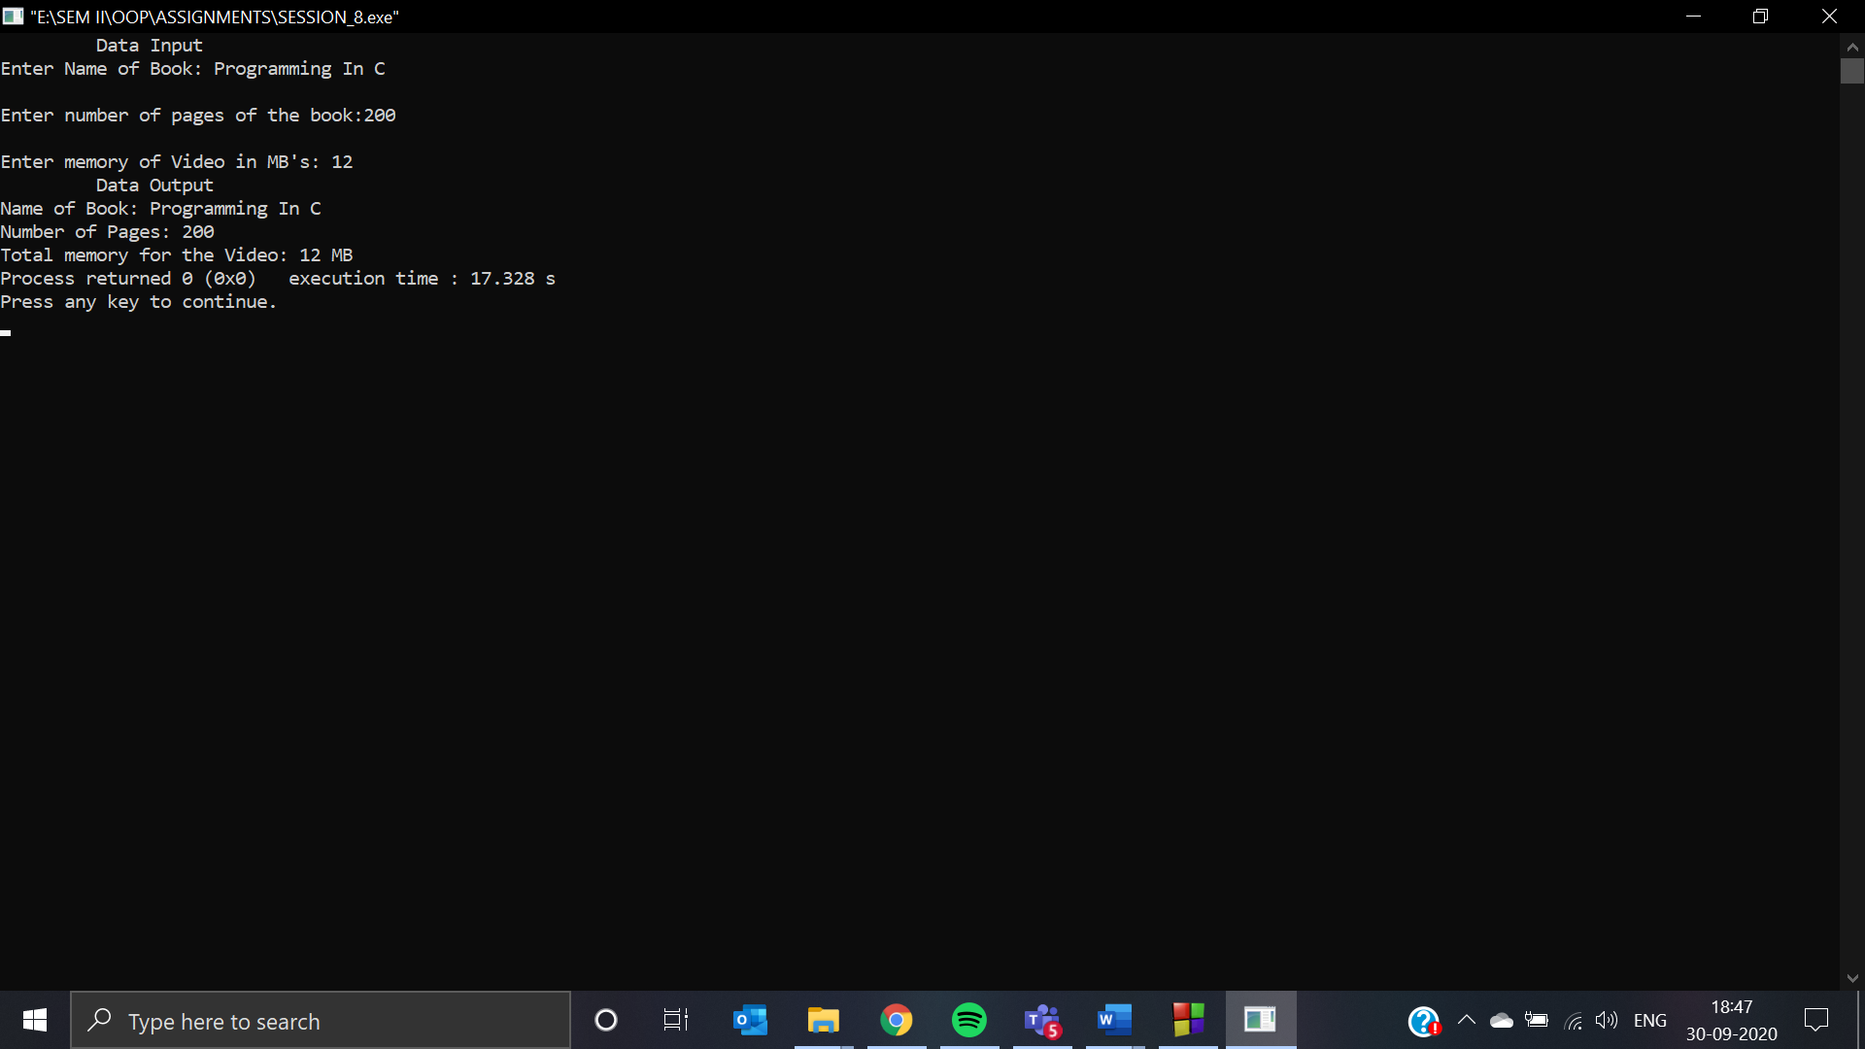

1. **Depict the following class hierarchy and assume the suitable member functions:**

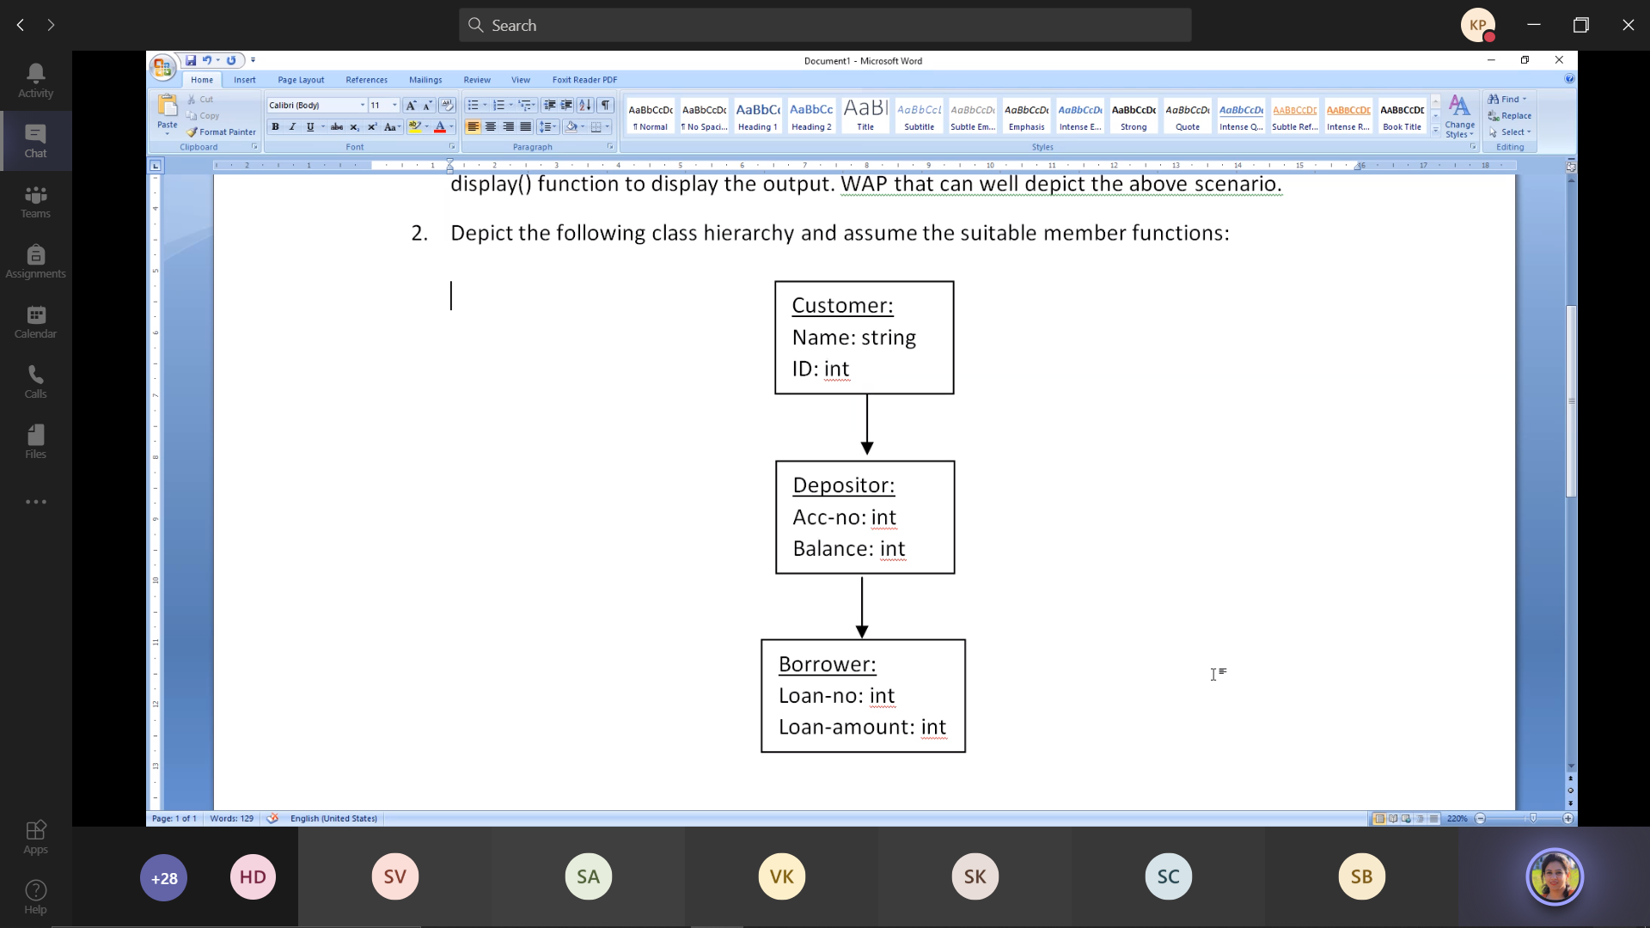

**ANS:**

**CODE:** #include<iostream>

#include<conio.h>

#include<stdio.h>

using namespace std;

class customer

{

protected:

int custid,accno,bal,lnno,lnamt;

char custnm[50];

public:

void getdat()

{

cout<<"\nEnter Name of Customer: ";

gets(custnm);

}

void display()

{

cout<<"\nCustomer Name: "<<custnm;

}

};

class depositor:public customer

{

int add_accno,add_bal;

public:

void getdat()

{

cout<<"\nRole as a DEPOSITOR.....";

cout<<"\nEnter your account number where you have to deposit the amount:";

cin>>add_accno;

accno = add_accno;

cout<<"\nEnter the money you want to deposit:";

cin>>add_bal;

bal = add_bal;

}

void display()

{

cout<<"\n\nRole as a DEPOSITOR.....";

cout<<"\nAccount Number: "<<accno;

cout<<"\nMoney Deposited: "<<bal;

}

};

class borrower:public depositor

{

int add_lnno,add_lnamt;

public:

void getdat()

{

cout<<"\nRole as a BORROWER.....";

cout<<"\nEnter your loan number:";

cin>>add_lnno;

lnno = add_lnno;

cout<<"\nEnter the loan money you want:";

cin>>add_lnamt;

lnamt = add_lnamt;

}

void display()

{

cout<<"\n\nRole as a BORROWER.....";

cout<<"\nLoan Number: "<<lnno;

cout<<"\nLoan Amount: "<<lnamt;

}

};

int main()

{

depositor d;

borrower b;

cout<<"\t Data Input";

d.customer::getdat();

d.getdat();

b.getdat();

cout<<"\n\n\t Data Output";

d.customer::display();

d.display();

b.display();

return 0;

}

**OUTPUT:**

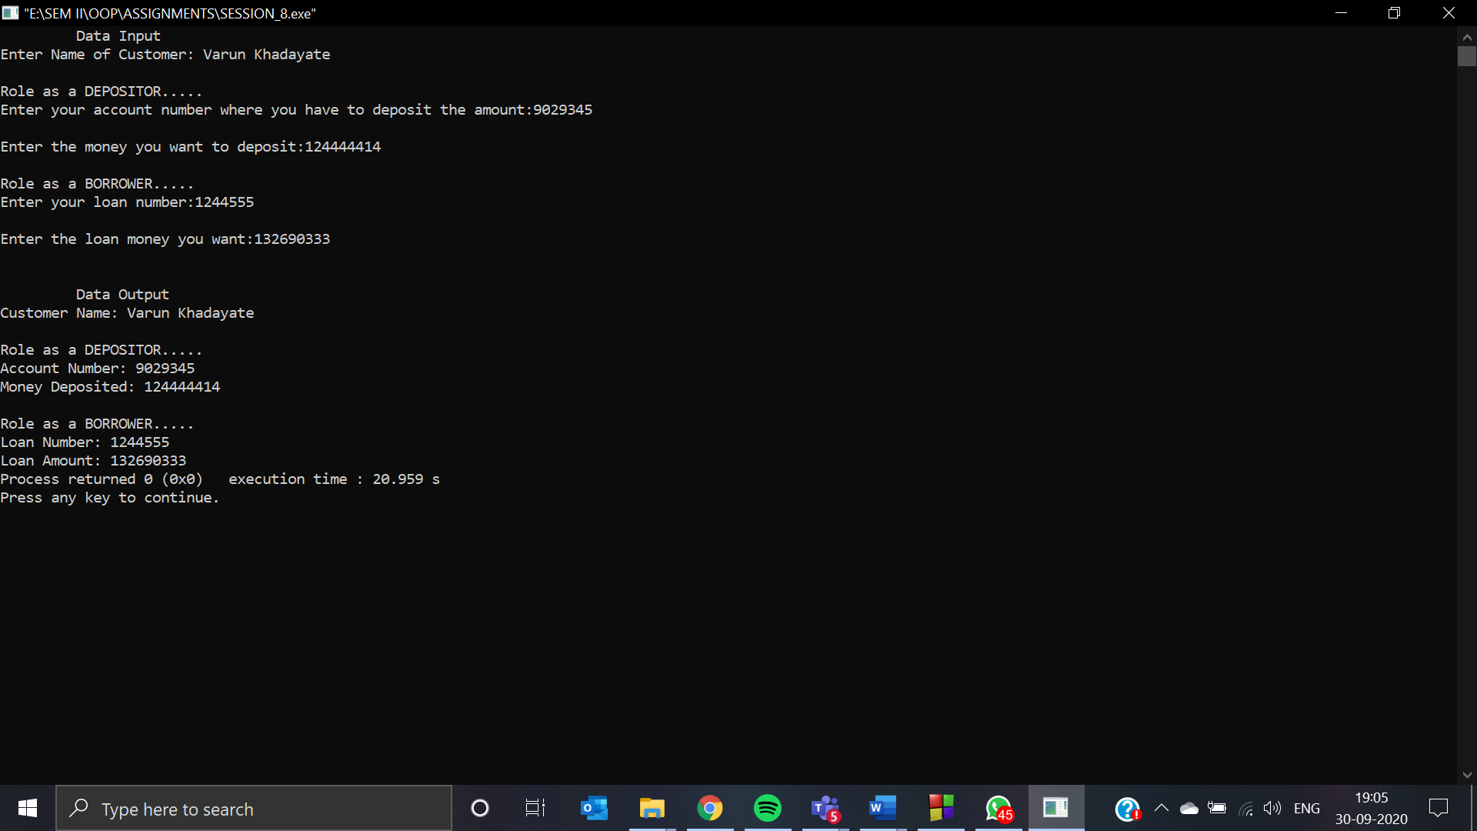

1. **Show with the help of a suitable example code: "ambiguity problem in multiple inheritance".**

**ANS:**

**CODE:** #include<iostream>

#include<conio.h>

using namespace std;

class gpa

{

public:

int gp;

};

class rollno : public gpa

{

public:

int rno;

};

class sapid : public gpa

{

public:

int sid;

};

class year : public rollno,public sapid

{

public:

int yr;

};

int main()

{

year yer;

yer.rollno::gp = 38;

yer.sapid::gp = 40;

yer.rno = 16;

yer.sid = 7036028;

yer.yr = 2;

cout<<"GPA from class rollno::"<<yer.rollno::gp;

cout<<"\nGPA from class sapid::"<<yer.sapid::gp;

cout<<"\nRoll No:"<<yer.rno;

cout<<"\nSap ID:"<<yer.sid;

cout<<"\nYear:"<<yer.yr;

return 0;

}

**OUTPUT:**

